1. Install Solidworks correctly to ensure that Solidworks Cam can run normally;
2. Copy Carvera-3axis.ctl and Carvera-3axis.lng to the directory of C:\ProgramData\SOLIDWORKS\SOLIDWORKS CAM 20XX\Posts\Mill;
3. Create a CAM project, edit machine partmeters;

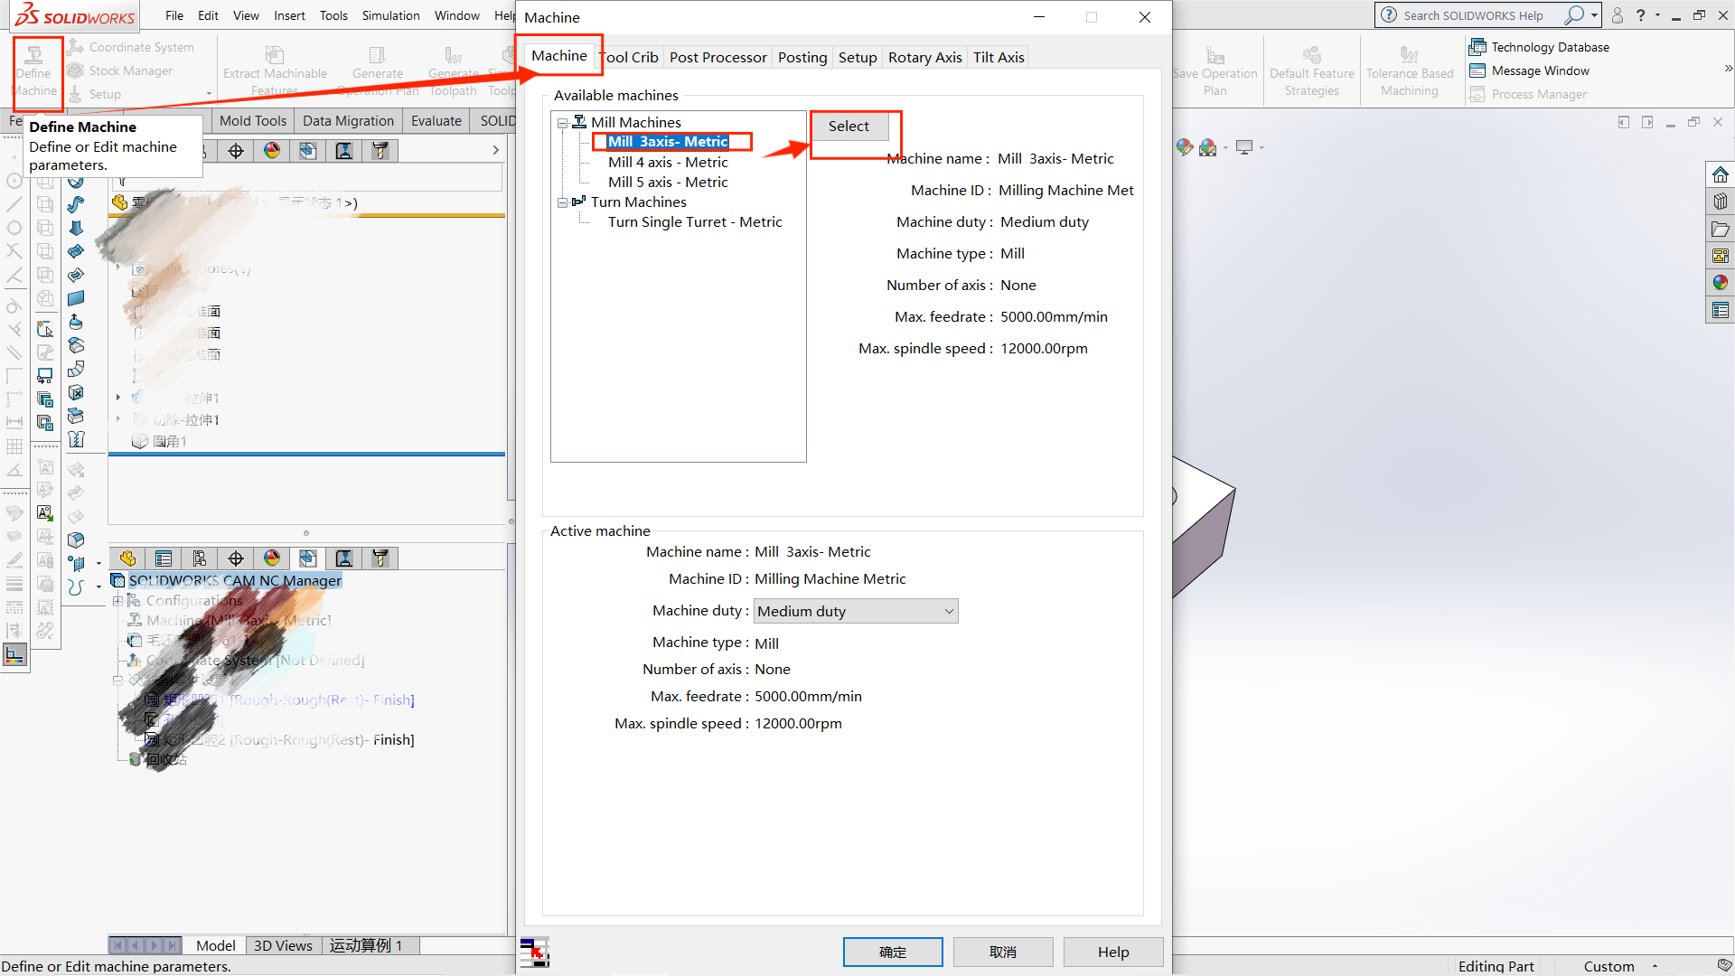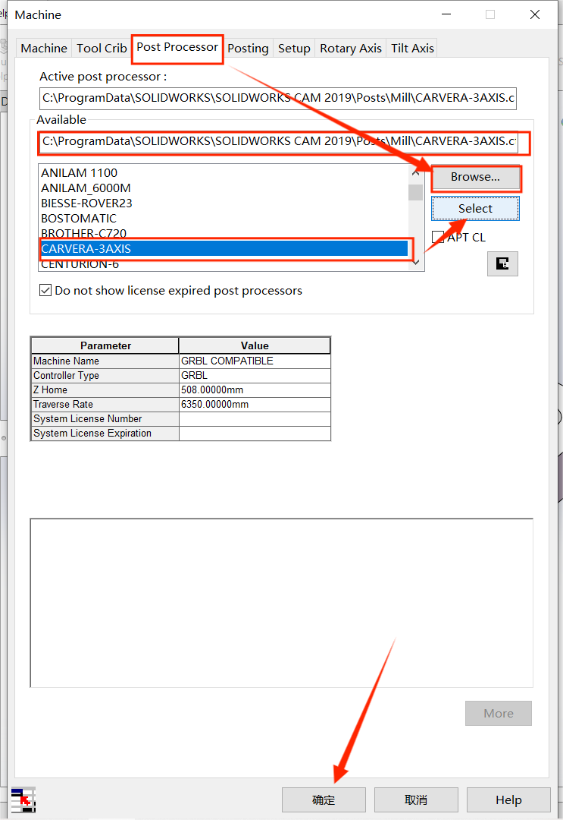

1. Generate Gcode to the directory of C:\ProgramFiles(x86)\CarveraController\gcodes ;